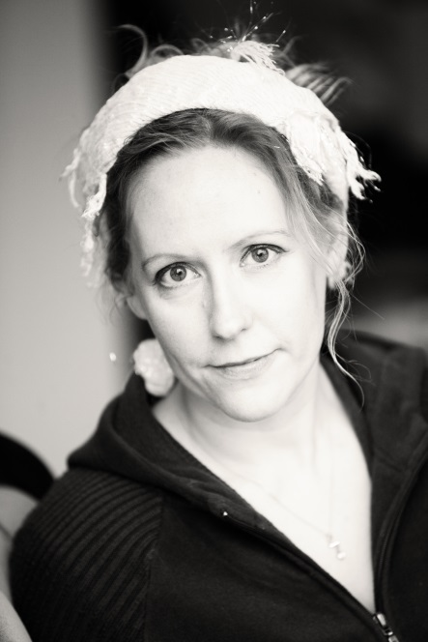
Vicky Ellis
Tel: 07948382099
Email: vickyellis@gmail.com
Websites:
http://vickyellis.weebly.com/
http://www.altblackpool.co.uk/
http://deadgoodpoets.blogspot.co.uk/search/label/vicky
http://www.linkedin.com/pub/vicky-ellis/46/a51/220

Skills
Copy Editing, Copywriting, Blogging, Research, Workshop Facilitation, Teaching, Performance, Presentation, Event Hosting, Event Planning, Review Writing, Storytelling, Creative Writing, Poetry, SEO, Interviewing, Music, Film-making, Origami, Crafts

Creative Projects/Event Organisation
2003 Communal Construction – Creator/editor of online writing project
2010 The Reclamation Project – Editor/producer of poetry pamphlet
2011 Blackpool Arts Centre – Creator/moderator of online arts group (ongoing)
2012 Unconventional Attitudes – Writer/performer/organiser/promoter of storytelling performance
2012 Darling Buds – Event organiser/performer at poetry and literature event in celebration of women at the New Continental, Preston
2012 Tales of Love and Loss – Event organiser for storytelling at Blackpool Library
2013 Pelts to Petticoats – Workshop facilitator and writer for historical poetry anthology
2013 On the Shoulders of Giants – Event organiser for fringe event at Blackpool Wordpool Festival
2013 1,000 Poets for Change – Event organiser/performer of poetry event
2013 Ice Cream & Dream Night –Event organiser/compere at poetry and art event in collaboration with Grundy Art Gallery and Arts for Health
2013 Poor – Project Leader/writer for illustrated poetry publication (ongoing)

Performer/Guest Artist
Poet
2010 Domina – Performance of a poem written for Earth Day
2011 Insatiable Sea – Speaker/Performer on theme of Equality and Diversity for conference at Blackpool & Fylde College
2011-2013 LDGP – Compere at monthly poetry nights for Lancashire Dead Good Poets
2011 Diversions – Guest editor for poetry and short story mini-anthologies
2012 Brewery Arts Centre – Guest poet
2012 Sanctuary – Guest poet at Lancaster Library
2013 Montgomery High School Literature Festival – Guest Speaker and Judge for students’ creative projects
2013 Grand Words One Act Play Competition – Final Judge
Actor
2012 Going Solo – Actor in two short plays by David Riley at Wordpool Literature Festival
2012 Haunted Blackpool – Performer of short story by David Riley for installation as part of Blackpool Illuminations
2013 How to Write a One Act Play – Actor in short play, One Last Time, by David Riley at Wordpool Literature Festival
2013 Freud Symposium – Actor in excerpt of play, Memories, Dreams, Reflections, by David Riley
Storyteller
2012 Ariadne/Thetis - Dock of the Bay Festival at Glasson Dock
2012 Aphrodite/Circe – Dreamfired Story Nights at Brigsteer, Kendal
2012 Aphrodite – Brewery Arts Centre at Kendal
2012 Unconventional Attitudes – Three days at Buxton Fringe Festival
2012 Unconventional Attitudes – Blackpool Wordpool Festival
2013 Alfresco Festival – Stories for children at Blackpool Cricket Club
2013 Soldier/Anansi –Dock of the Bay Festival at Glasson Dock
Singer
2009-2013 Myfi – Singer/Songwriter performances in Blackpool and Lancaster

Workshop Facilitator
2011 Novel Writing Workshop for Blackpool Wordpool Festival
2012 Arts for Health – Three poetry workshops on senses and emotions
2013 DGP Workshops – Monthly poetry workshops on a range of themes at Central Library
2013 Up for Arts – Live poetry workshop on Radio Lancashire
2013 LGBTea – Poetry workshop for LGBT History Month event at Blackpool Town Hall
2013 Arts for Health – Ten poetry workshops over five weeks inspired by Kelly Richardson’s Twilight Avenger
2013 Montgomery High School – Two poetry workshops for young people aged 11 to 14
2013 Origami – Craft for children aged 3+ at Wordpool Family Fun Day
2013 Origami – Craft for children aged 3+ at Blackpool International Festival
2013 Lion Mask Workshop – Craft for children aged 3+ at Stanley Park
2013 Arts for Health – Four poetry workshops over two weeks in collaboration with artist, Jo Berry inspired by Zoe Beloff’s Dreamland exhibition

Publications
Poetry
‘Elephant in the Womb’ in Breadcrumb Scabs Magazine (2010)
‘Good Cause Is’ in Disingenuous Twaddle (2010)
‘Soundcloud’ poetry and music improvised collaboration (2010)
‘Not small but distant’ and ‘Seven carrots for the elephant’ in The Reclamation Project (2010)
‘Insatiable Sea’ in Wordpool Paper (2012)
‘Smoke’ video publication of poetry performance (2012)
‘The Burglar’s Oath’ in Poetry24 (2012)
‘Cedar Cub’ in Vine Leaves Literary Journal (2012)
'Blackpool Tower', 'Black(spiritual retreat)pool' and 'Eighteen Eighty Nine' in A Poet’s Guide to Blackpool (2012)
‘What I have learned about kissing’ in How to Write Erotic Fiction (2013)
‘Iffy’ in Defenestration (2013)
‘The Mermaid’s Opinion on Fried Liver’ in Pelts to Petticoats (2013)
‘Mrs Tucker’ and ‘Wonderland’ in Featherlit (2013)
‘The Problem of All Those Bodies’ – poetry collection (2013)

Fiction
‘The Oldest Confession’ in Behind the Front (2010)
‘The Colonel’ – fantasy/humour novel (2011)
‘Hell for Leather’ in Slave Girls: Erotic Tales of Submission (2014)

Non-fiction
Book Reviews for Curledup.com (2002)
Reviews and Interviews for Lancashire Writing Hub (2011-2012)
70+ articles for altblackpool (2012-2013)
120+ blog posts for Blackpool Dead Good Poets’ Blog (2011-2013)

Awards/Achievements
2001 Burning Man Festival, USA – Short poem featured in exhibition dedicated to Neil Gaiman’s Sandman graphic novels
2008 National Novel Writing Contest – Completion of a novel in 30 days
2009 National Songwriting Competition – Semi-finalist for Ice Cream
2010 Winner of Creative Edge poetry competition
2010, 2011, 2012 Award for Academic Excellence – Blackpool and Fylde College
2011 Winner of Lancaster Spotlight Slam as part of Litfest with poem: One Two
2012 Winner: Radio Wave Website of the Year – for the Blackpool Dead Good Poets’ Blog
2012 Guest Editor for Lancashire Writing Hub
2012 Winner: Spoken Word Award at Buxton Fringe Festival for Unconventional Attitudes
2012 Nomination: New Writing Award at Buxton Fringe Festival for Unconventional Attitudes
2013 Nomination: Radio Wave Website of the Year – for altblackpool and Blackpool Dead Good Poets’ Blog

Groups
Lancashire Dead Good Poets – Blackpool-based poetry group
Monkeyrack – Lancaster-based writing collective
Aunty Social – Blackpool-based community arts collective
North West Poets – Lancashire-based poetry collective

Volunteering
2011-2013 Lancashire Dead Good Poets – Steering Committee
2012 Beyond the Border Storytelling Festival – Artist liaison over five days
2012-2013 Altblackpool – Editor and copywriter
2012 Lancashire Writing Hub – Guest Editor
2013 Under the Town – Steward at young people’s festival in the Winter Gardens
2013 Wordpool Literature Festival – Steering Committee

